**SOLUTION ARCHITECTURE**

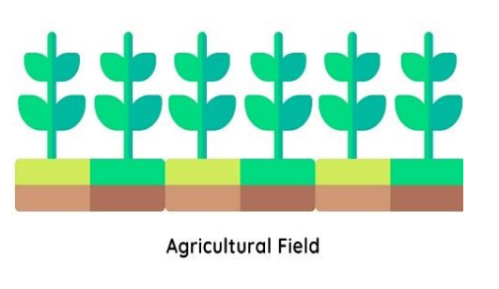

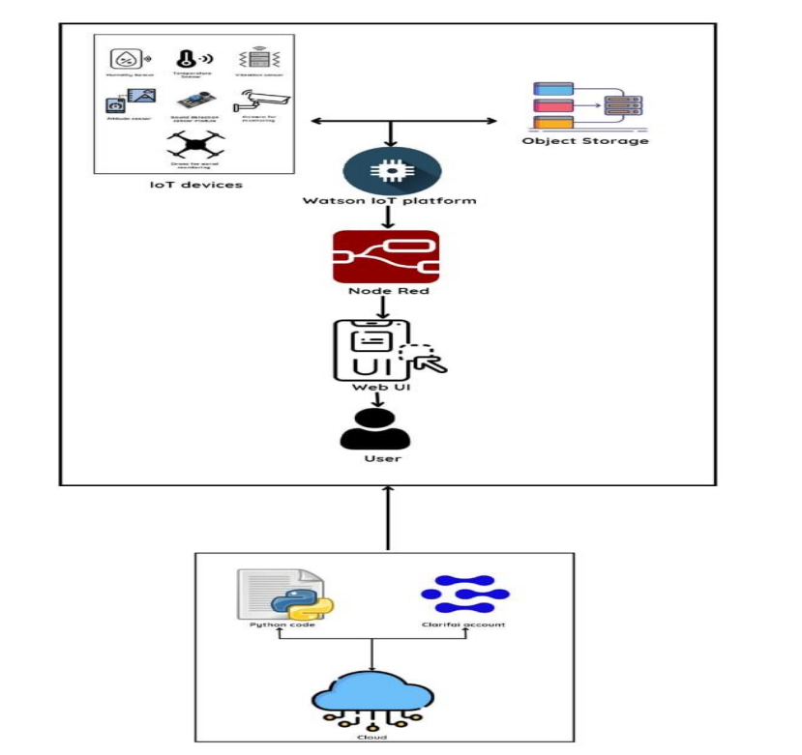

# Description:-

# The proposed solution comprises IoT Devices and Object storage connected together to the Watson IoT platform. IoT devices include a temperature sensor and humidity sensor to monitor climatic conditions, an altitude sensor which is attached to a drone for proper aerial monitoring, and a sound detection sensor module which will monitor sounds coming from animals/insects if any, and take necessary actions. Camera monitoring is also done for monitoring the animals trying to enter the field. The python code is loaded into the cloud using Clarify and the Watson platform is connected to Node-Red which in turn is connected and given to the user via Web UI